**Chapter 4**

**IMPLEMENTATION AND USER INTERFACE**

The implementation phase of the project is the development of the designs produced during the design phase. Through a series of screen shots and descriptions this section will show how the generic requirements of the applications have been met. User interface is the front-end application view to which user interacts in order to use the software. User can manipulate and control the software as well as hardware by means of user interface. Today, user interface is found at almost every place where digital technology exists, right from computers, mobile phones, cars, music players, airplanes, ships etc. User interface is part of software and is designed such a way that it is expected to provide the user insight of the software. UI provides fundamental platform for human-computer interaction. UI can be graphical, text-based, audio-video based, depending upon the underlying hardware and software combination. UI can be hardware or software or a combination of both.

* 1. **Database**

Perhaps the biggest and most important change is the database employed as it keeps track of your frequently used applications and helps user to achieve better hospitality and ease of access. Databases are the storehouses of the data used in the software systems. The data is stored in tables inside the database. Several tables are created for the manipulation of the data for the system. Two essential settings for a database are - the field that is unique for all the record occurrences. - the field used to set relation between tables.

* 1. **Layout**

The layout of the interface is constructed using java graphics library as well as certain graphics and pictures. A graphical representation of the GUI can be seen from fig. 4.1.

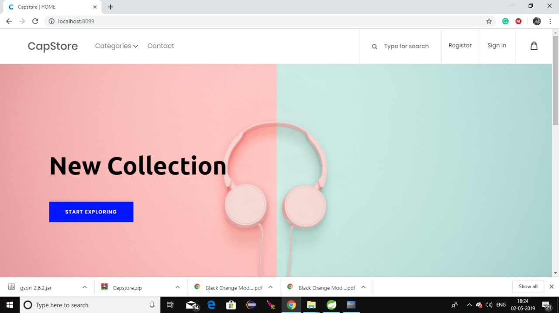

Figure 4.2.1 CapStore Home Page Layout

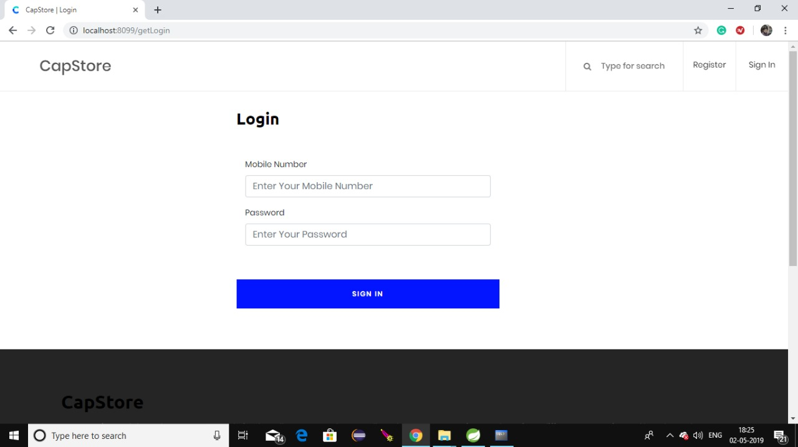

Figure 4.2.2 CapStore Login Layout

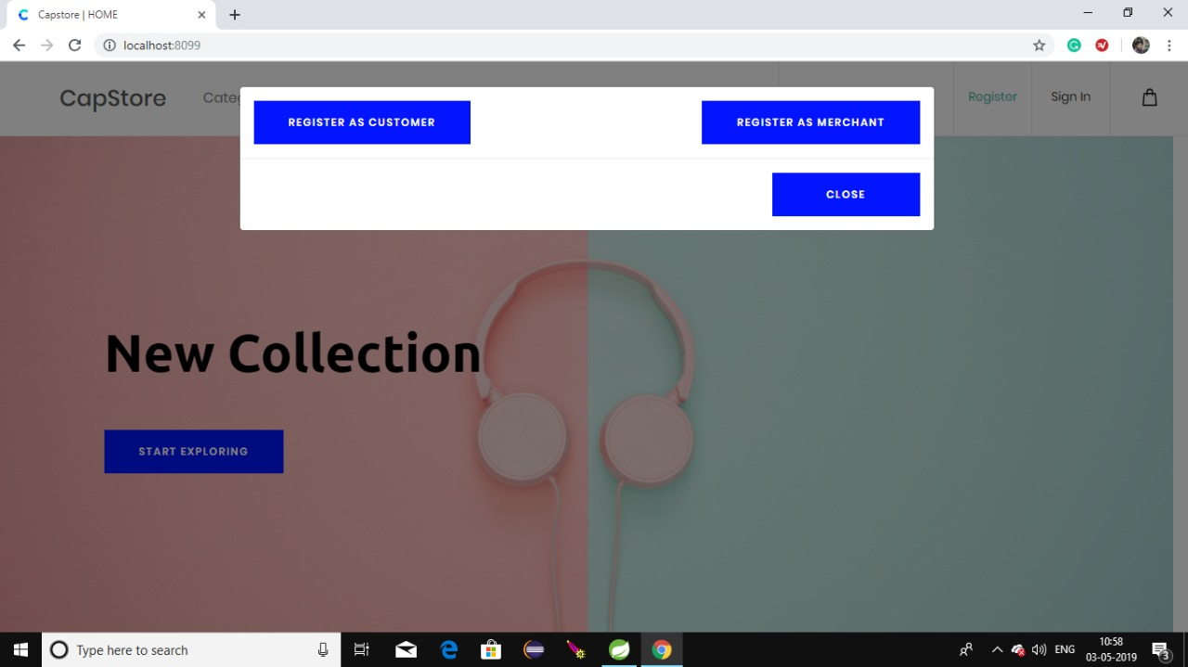

Figure 4.2.3 CapStore Register Selection Layout

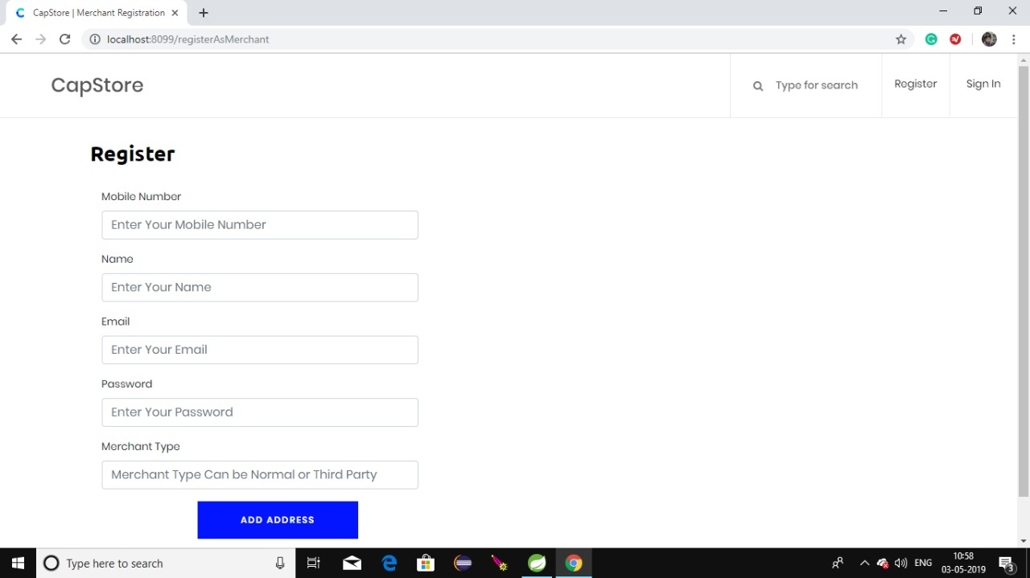

Figure 4.2.4 CapStore Merchant Register Layout

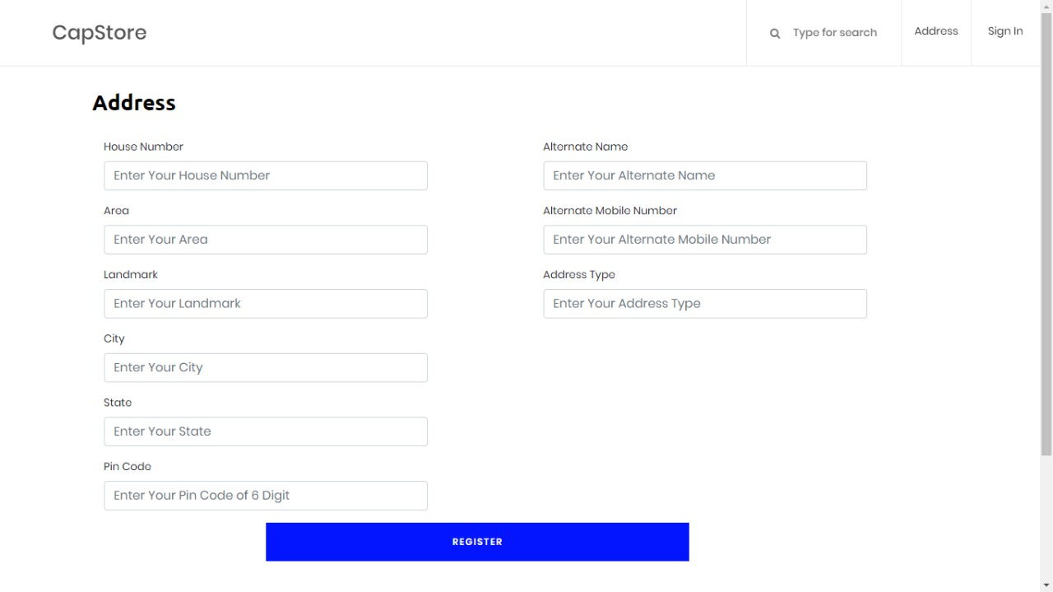

Figure 4.2.5 CapStore Add Address Layout